|  |
| --- |
| **RESUME BUILDER WEB-APP**  **21CSS101J – PROGRAMMING FOR PROBLEM-SOLVING**  **Mini Project Report**  *Submitted by*  **Saanvi Mahika [Reg. No.: RA2311003012125]**  **B.Tech. CSE - <<CORE>>**  **Vaibhav Verma [Reg. No.: RA2311003012125]**  **B.Tech. CSE - <<CORE>>**  **SRMIST-01.jpg**  **SCHOOL OF COMPUTING**  **COLLEGE OF ENGINEERING AND TECHNOLOGY**  **SRM INSTITUTE OF SCIENCE AND TECHNOLOGY**  **(Under Section 3 of UGC Act, 1956)**  S.R.M. NAGAR, KATTANKULATHUR – 603 203  CHENGALPATTU DISTRICT  **November 2023**  **COLLEGE OF ENGINEERING AND TECHNOLOGY**  **SRM INSTITUTE OF SCIENCE AND TECHNOLOGY**  **(Under Section 3 of UGC Act, 1956)**  S.R.M. NAGAR, KATTANKULATHUR – 603 203  **SRMIST-01.jpg**  **BONAFIDE CERTIFICATE**  Certified that Mini project report titled ________________________________________________ is the bonafide work of Reg.No___________________________________Name___________________who carried out the minor project under my supervision. Certified further, that to the best of my knowledge, the work reported herein does not form any other project report or dissertation on the basis of which a degree or award was conferred on an earlier occasion on this or any other candidate.  **SIGNATURE SIGNATURE**  **(GUIDE) (HEAD OF THE DEPARTMENT)** |

**TABLE OF CONTENTS**

|  |  |  |
| --- | --- | --- |
| **S No.** | **Title** | **Page No.** |
| 1 | Problem Statement |  |
| 2 | Methodology / Procedure/ Algorithm |  |
| 3 | Flowchart |  |
| 4 | Coding (C/Python) |  |
| 5 | Front-end code (HTML, CSS, Javascript) [Optional] |  |
| 6 | Modules of the proposed work |  |
| 7 | Results/Screenshots |  |
| 8 | Conclusion |  |
| 9 | References |  |

1. **Problem Statement : Resume Builder Web Application**

In today's competitive job market, individuals are constantly seeking ways to stand out and showcase their professional qualifications effectively. Traditional resume-building methods often lack modern features and accessibility, making it challenging for users to create, manage, and present their resumes efficiently. To address this need, our goal is to develop a Resume Builder Web Application, providing users with a user-friendly platform to craft, customize, and share compelling resumes.

The problem is further compounded by the diverse needs of job seekers, ranging from recent graduates to seasoned professionals, each requiring a tailored approach to resume creation.

To address these issues, there is a need for a comprehensive web-based resume builder application that provides a user-friendly interface. The application should cater to the specific requirements of different user demographics, ensuring that each user can create a compelling resume that aligns with their career goals.

The goal is to develop a robust and intuitive web application that empowers users to create professional resumes efficiently, increases their chances of securing job opportunities, and simplifies the overall job application process.

1. **Methodology / Procedure/ Algorithm**

The methodology involved utilizing Django, Python, HTML, CSS, and Bootstrap to create a robust web application. The procedure included implementing a user signup/login system, profile form for information input, integrating Django Summernote for customization, and rendering the entered data into a predefined CV template.

Procedure involved utilizing Django, Python, HTML, CSS, and Bootstrap to create a robust web application.:

1. **Add Resume**

- Handle the POST request to add a resume.

- Read resume fields from the request object.

- Create a Profile object with the resume fields.

- Save the Profile object in the database.

- Redirect to the addResume page with a success message.

2. **List Resumes**

- Read the current user's username from the request object.

- Check if any profiles exist for the current user.

- If profiles exist, retrieve and pass them to the ListResume.html template for rendering.

3. **View Resume**

- Retrieve a user's profile using their ID from the database.

- Pass the profile data to the viewResume.html template for rendering.

**3. Flow chart**

1. **Coding (C/Python)**

from django.urls import path  
from resumeBuilder import views  
  
urlpatterns = [  
 path('', views.index, name='index'),  
 path('signup', views.signupPage, name='signupPage'),  
 path('login', views.loginPage, name='loginPage'),  
 path('logout', views.logoutPage, name='logoutPage'),  
 path('viewResume', views.viewResume, name='viewResume'),  
 path('addResume', views.addResume, name='addResume'),  
 path('listResume', views.listResume, name='listResume'),  
]

def addResume(request): #we have function named add resume, with request parameter  
 if request.method == "POST":  
 userid = request.POST.get("userid") #read all resume fields from request object  
 name =request.POST.get("name")   
 objective =request.POST.get("objective")   
 address =request.POST.get("address")   
 phoneno =request.POST.get("phoneno")   
 email =request.POST.get("email")   
 github =request.POST.get("github")  
 linkedin =request.POST.get("linkedin")   
 university1 =request.POST.get("university1")   
 degree1 =request.POST.get("degree1")   
 stream1 =request.POST.get("stream1")   
 currentYear1 =request.POST.get("currentYear1")   
 univStartingYear1 =request.POST.get("univStartingYear1")   
 univPassingYear1 =request.POST.get("univPassingYear1")   
 univResult1 =request.POST.get("univResult1")  
 university2 =request.POST.get("university2")   
 degree2 =request.POST.get("degree2")   
 stream2 =request.POST.get("stream2")   
 currentYear2 =request.POST.get("currentYear2")   
 univStartingYear2 =request.POST.get("univStartingYear2")   
 univPassingYear2 =request.POST.get("univPassingYear2")   
 univResult2 =request.POST.get("univResult2")  
 intermediateSchool =request.POST.get("intermediateSchool")   
 intermediateSubjects =request.POST.get("intermediateSubjects")   
 intermediateStartingYear =request.POST.get("intermediateStartingYear")   
 intermediatePassingYear =request.POST.get("intermediatePassingYear")   
 intermediateMarks =request.POST.get("intermediateMarks")   
 highSchool =request.POST.get("highSchool")   
 highSchoolSubjects =request.POST.get("highSchoolSubjects")   
 highSchoolStartingYear =request.POST.get("highSchoolStartingYear")   
 highSchoolPassingYear =request.POST.get("highSchoolPassingYear")   
 highSchoolMarks =request.POST.get("highSchoolMarks")   
 jobTitle1 =request.POST.get("jobTitle1")   
 jobStartDate1 =request.POST.get("jobStartDate1")   
 jobEndDate1 =request.POST.get("jobEndDate1")   
 jobDescription1 =request.POST.get("jobDescription1")   
 jobTitle2 =request.POST.get("jobTitle2")   
 jobStartDate2 =request.POST.get("jobStartDate2")   
 jobEndDate2 =request.POST.get("jobEndDate2")   
 jobDescription2 =request.POST.get("jobDescription2")   
 jobTitle3 =request.POST.get("jobTitle3")   
 jobStartDate3 =request.POST.get("jobStartDate3")   
 jobEndDate3 =request.POST.get("jobEndDate3")   
 jobDescription3 =request.POST.get("jobDescription3")   
 jobTitle4 =request.POST.get("jobTitle4")   
 jobStartDate4 =request.POST.get("jobStartDate4")   
 jobEndDate4 =request.POST.get("jobEndDate4")   
 jobDescription4 =request.POST.get("jobDescription4")   
 jobTitle5 =request.POST.get("jobTitle5")   
 jobStartDate5 =request.POST.get("jobStartDate5")   
 jobEndDate5 =request.POST.get("jobEndDate5")   
 jobDescription5 =request.POST.get("jobDescription5")   
 projectTitle1 =request.POST.get("projectTitle1")   
 projectStartDate1 =request.POST.get("projectStartDate1")   
 projectEndDate1 =request.POST.get("projectEndDate1")   
 projectDescription1 =request.POST.get("projectDescription1")   
 projectTitle2 =request.POST.get("projectTitle2")   
 projectStartDate2 =request.POST.get("projectStartDate2")   
 projectEndDate2 =request.POST.get("projectEndDate2")   
 projectDescription2 =request.POST.get("projectDescription2")   
 projectTitle3 =request.POST.get("projectTitle3")   
 projectStartDate3 =request.POST.get("projectStartDate3")   
 projectEndDate3 =request.POST.get("projectEndDate3")   
 projectDescription3 =request.POST.get("projectDescription3")   
 projectTitle4 =request.POST.get("projectTitle4")   
 projectStartDate4 =request.POST.get("projectStartDate4")   
 projectEndDate4 =request.POST.get("projectEndDate4")   
 projectDescription4 =request.POST.get("projectDescription4")   
 projectTitle5 =request.POST.get("projectTitle5")   
 projectStartDate5 =request.POST.get("projectStartDate5")   
 projectEndDate5 =request.POST.get("projectEndDate5")   
 projectDescription5 =request.POST.get("projectDescription5")   
 skillDetail =request.POST.get("skillDetail")   
 languageDetail =request.POST.get("languageDetail")   
 areaOfInterest =request.POST.get("areaOfInterest")   
 extracurricularDetail =request.POST.get("extracurricularDetail")   
  
 profile = Profile (userid=userid, name=name, objective=objective, address=address, phoneno=phoneno, email=email, github=github, linkedin=linkedin, university1=university1, degree1=degree1, stream1=stream1, currentYear1=currentYear1, univStartingYear1=univStartingYear1, univPassingYear1=univPassingYear1, univResult1=univResult1, university2=university2, degree2=degree2, stream2=stream2, currentYear2=currentYear2, univStartingYear2=univStartingYear2, univPassingYear2=univPassingYear2, univResult2=univResult2, intermediateSchool=intermediateSchool, intermediateSubjects=intermediateSubjects, intermediateStartingYear=intermediateStartingYear, intermediatePassingYear=intermediatePassingYear, highSchool=highSchool, highSchoolSubjects=highSchoolSubjects, highSchoolStartingYear=highSchoolStartingYear, highSchoolPassingYear=highSchoolPassingYear, highSchoolMarks=highSchoolMarks, jobTitle1=jobTitle1, jobStartDate1=jobStartDate1, jobEndDate1=jobEndDate1, jobDescription1=jobDescription1, jobTitle2=jobTitle2, jobStartDate2=jobStartDate2, jobEndDate2=jobEndDate2, jobDescription2=jobDescription2, jobTitle3=jobTitle3, jobStartDate3=jobStartDate3, jobEndDate3=jobEndDate3, jobDescription3=jobDescription3, jobTitle4=jobTitle4, jobStartDate4=jobStartDate4, jobEndDate4=jobEndDate4, jobDescription4=jobDescription4, jobTitle5=jobTitle5, jobStartDate5=jobStartDate5, jobEndDate5=jobEndDate5, jobDescription5=jobDescription5, projectTitle1=projectTitle1, projectStartDate1=projectStartDate1, projectEndDate1=projectEndDate1, projectDescription1=projectDescription1, projectTitle2=projectTitle2, projectStartDate2=projectStartDate2, projectEndDate2=projectEndDate2, projectDescription2=projectDescription2, projectTitle3=projectTitle3, projectStartDate3=projectStartDate3, projectEndDate3=projectEndDate3, projectDescription3=projectDescription3, projectTitle4=projectTitle4, projectStartDate4=projectStartDate4, projectEndDate4=projectEndDate4, projectDescription4=projectDescription4, projectTitle5=projectTitle5, projectStartDate5=projectStartDate5, projectEndDate5=projectEndDate5, projectDescription5=projectDescription5, skillDetail=skillDetail, languageDetail=languageDetail, areaOfInterest=areaOfInterest, extracurricularDetail=extracurricularDetail)  
 profile.save() #profile database object using above resume fields and stored it  
  
 messages.success(request, "Your resume has been successfully added!")  
 return redirect('/addResume')  
  
 return render(request, 'addResume.html')

def viewResume(request, id):  
 user_profile = Profile.objects.get(pk=id) #primarykey  
 return render(request, "viewResume.html", {'user_profile':user_profile})  
 #user_profile context passed to html template  
  
def listResume(request):  
 current_user = request.user.username #read current username from request object  
  
 if Profile.objects.filter(userid = current_user).exists(): #profile-database,obj-row,filter-useridvalue=currentuser  
 list_of_resume = Profile.objects.filter(userid = current_user) #userid=currentuser, assign the id to list  
 return render(request, "listResume.html", {'profile':list_of_resume}) #display  
 #profile context passed to html template  
 return render(request, "listResume.html")

**5. Front-end code (HTML, CSS, Javascript)**

**{% extends 'base.html' %}**

**<!-- changing title of page -->**

**{% block title %}**

**Add Resume**

**{% endblock title %}**

**{% block body %}**

**<!-- creating container for adding details -->**

**<div class="container">**

**<div class="row pt-2 mb-3">**

**<div class="text-center col-md-6"></div>**

**<div class="col-md-12 mt-3 mb-3 ml-2 mr-2 my-auto border border-dark border-2 rounded-3">**

**<h3 class="text-center mb-3 mt-3">ADD DETAILS FOR RESUME</h3>**

**{% for message in messages %}**

**<div class="alert alert-{{message.tags}} alert-dismissible fade show" role="alert">**

**{{message}}**

**<button type="button" class="btn-close" data-bs-dismiss="alert" aria-label="Close"></button>**

**</div>**

**{% endfor %}**

**<!-- creating form for adding resume details -->**

**<form action="/addResume" method="post">{% csrf_token %}**

**<label for="userid" class="form-label">User ID*</label>**

**<div class="form-group">**

**<input type="text" class="form-control mb-3" id="userid" name="userid" value="{{user.username}}"**

**placeholder="Enter your resume byuilder user id" required>**

**</div>**

**<label for="name" class="form-label">Full Name*</label>**

**<div class="form-group">**

**<input type="text" class="form-control mb-3" id="name" name="name"**

**placeholder="Enter your full name" required>**

**</div>**

**<label for="objective" class="form-label">Objective*</label>**

**<div class="form-group">**

**<textarea id="objective" name="objective" cols="90" rows="3" class="form-control"**

**placeholder="Enter something about you" required></textarea>**

**</div>**

**<label for="address" class="form-label">Address*</label>**

**<div class="form-group">**

**<input type="text" class="form-control mb-3" id="address" name="address"**

**placeholder="Enter your address" required>**

**</div>**

**<label for="tel" class="form-label">Phone Number*</label>**

**<div class="form-group">**

**<input type="number" class="form-control mb-3" id="phoneno" name="phoneno"**

**placeholder="Enter your phone number" required>**

**</div>**

**<label for="email" class="form-label">Email ID*</label>**

**<div class="form-group">**

**<input type="email" class="form-control mb-3" id="email" name="email"**

**placeholder="Enter your email id" required>**

**</div>**

**<label for="github" class="form-label">Git Hub profile link</label>**

**<div class="form-group">**

**<input type="url" class="form-control mb-3" id="github" name="github"**

**placeholder="Enter your github profile link">**

**</div>**

**<label for="linkedin" class="form-label">Linkedin Profile link</label>**

**<div class="form-group">**

**<input type="url" class="form-control mb-3" id="linkedin" name="linkedin"**

**placeholder="Enter your linkedin profile link">**

**</div>**

**<label for="university1" class="form-label">University Name</label>**

**<div class="form-group">**

**<input type="text" class="form-control mb-3" id="university1" name="university1"**

**placeholder="Enter your University Name">**

**</div>**

**<label for="degree1" class="form-label">Degree</label>**

**<div class="form-group">**

**<input type="text" class="form-control mb-3" id="degree1" name="degree1"**

**placeholder="Enter your degree">**

**</div>**

**<label for="stream1" class="form-label">Stream</label>**

**<div class="form-group">**

**<input type="text" class="form-control mb-3" id="stream1" name="stream1"**

**placeholder="Enter your Stream">**

**</div>**

**<label for="currentYear1" class="form-label">University Current Year</label>**

**<div class="form-group">**

**<input type="text" class="form-control mb-3" id="currentYear1" name="currentYear1"**

**placeholder="Enter the current year which you are studying in">**

**</div>**

**<label for="univStartingYear1" class="form-label">University Starting Year</label>**

**<div class="form-group">**

**<input type="month" class="form-control mb-3" id="univStartingYear1" name="univStartingYear1"**

**placeholder="Enter your university starting year">**

**</div>**

**<label for="univPassingYear1" class="form-label">University Passing Year</label>**

**<div class="form-group">**

**<input type="month" class="form-control mb-3" id="univPassingYear1" name="univPassingYear1"**

**placeholder="Enter your university passing year">**

**</div>**

**<label for="univResult1" class="form-label">University Result</label>**

**<div class="form-group">**

**<input type="text" class="form-control mb-3" id="univResult1" name="univResult1"**

**placeholder="Enter your university score">**

**</div>**

**<label for="university2" class="form-label">University Name</label>**

**<div class="form-group">**

**<input type="text" class="form-control mb-3" id="university2" name="university2"**

**placeholder="Enter your University Name">**

**</div>**

**<label for="degree2" class="form-label">Degree</label>**

**<div class="form-group">**

**<input type="text" class="form-control mb-3" id="degree2" name="degree2"**

**placeholder="Enter your degree">**

**</div>**

**<label for="stream2" class="form-label">Stream</label>**

**<div class="form-group">**

**<input type="text" class="form-control mb-3" id="stream2" name="stream2"**

**placeholder="Enter your Stream">**

**</div>**

**<label for="currentYear2" class="form-label">University Current Year</label>**

**<div class="form-group">**

**<input type="text" class="form-control mb-3" id="currentYear" name="currentYear2"**

**placeholder="Enter the current year which you are studying in">**

**</div>**

**<label for="univStartingYear2" class="form-label">University Starting Year</label>**

**<div class="form-group">**

**<input type="month" class="form-control mb-3" id="univStartingYear2" name="univStartingYear2"**

**placeholder="Enter your university starting year">**

**</div>**

**<label for="univPassingYear2" class="form-label">University Passing Year</label>**

**<div class="form-group">**

**<input type="month" class="form-control mb-3" id="univPassingYear2" name="univPassingYear2"**

**placeholder="Enter your university passing year">**

**</div>**

**<label for="univResult2" class="form-label">University Result</label>**

**<div class="form-group">**

**<input type="text" class="form-control mb-3" id="univResult2" name="univResult2"**

**placeholder="Enter your university score">**

**</div>**

**<label for="intermediateSchool" class="form-label">Intermediate School Name</label>**

**<div class="form-group">**

**<input type="text" class="form-control mb-3" id="intermediateSchool" name="intermediateSchool"**

**placeholder="Enter your intermediate school name">**

**</div>**

**<label for="intermediateSubjects" class="form-label">Intermediate Board and Subjects</label>**

**<div class="form-group">**

**<input type="text" class="form-control mb-3" id="intermediateSubjects" name="intermediateSubjects"**

**placeholder="Enter your intermediate subjects you had">**

**</div>**

**<label for="intermediateStartingYear" class="form-label">Intermediate Starting Year</label>**

**<div class="form-group">**

**<input type="month" class="form-control mb-3" id="intermediateStartingYear"**

**name="intermediateStartingYear" placeholder="Enter your intermediate starting year">**

**</div>**

**<label for="intermediatePassingYear" class="form-label">Intermediate Passing Year</label>**

**<div class="form-group">**

**<input type="month" class="form-control mb-3" id="intermediatePassingYear"**

**name="intermediatePassingYear" placeholder="Enter your intermediate passing year">**

**</div>**

**<label for="intermediateMarks" class="form-label">Intermediate Marks</label>**

**<div class="form-group">**

**<input type="text" class="form-control mb-3" id="intermediateMarks" name="intermediateMarks"**

**placeholder="Enter your intermediate marks">**

**</div>**

**<label for="highSchool" class="form-label">High School Name</label>**

**<div class="form-group">**

**<input type="text" class="form-control mb-3" id="highSchool" name="highSchool"**

**placeholder="Enter your high school name">**

**</div>**

**<label for="highSchoolSubjects" class="form-label">High School Board and Subjects</label>**

**<div class="form-group">**

**<input type="text" class="form-control mb-3" id="highSchoolSubjects" name="highSchoolSubjects"**

**placeholder="Enter your high school subjects you had">**

**</div>**

**<label for="highSchoolStartingYear" class="form-label">High School Starting Year</label>**

**<div class="form-group">**

**<input type="month" class="form-control mb-3" id="highSchoolStartingYear"**

**name="highSchoolStartingYear" placeholder="Enter your high school starting year">**

**</div>**

**<label for="highSchoolPassingYear" class="form-label">High School Passing Year</label>**

**<div class="form-group">**

**<input type="month" class="form-control mb-3" id="highSchoolPassingYear"**

**name="highSchoolPassingYear" placeholder="Enter your high school passing year">**

**</div>**

**<label for="highSchoolMarks" class="form-label">High School Marks</label>**

**<div class="form-group">**

**<input type="text" class="form-control mb-3" id="highSchoolMarks" name="highSchoolMarks"**

**placeholder="Enter your high school marks">**

**</div>**

**<label for="jobTitle1" class="form-label">Job Title</label>**

**<div class="form-group">**

**<input type="text" class="form-control mb-3" id="jobTitle1" name="jobTitle1"**

**placeholder="Enter your job details">**

**</div>**

**<label for="jobStartDate1" class="form-label">Job Starting Date</label>**

**<div class="form-group">**

**<input type="month" class="form-control mb-3" id="jobStartDate1" name="jobStartDate1"**

**placeholder="Enter your job's starting date">**

**</div>**

**<label for="jobEndDate1" class="form-label">Job Ending Date</label>**

**<div class="form-group">**

**<input type="month" class="form-control mb-3" id="jobEndDate1" name="jobEndDate1"**

**placeholder="Enter your job's ending date">**

**</div>**

**<label for="jobDescription1" class="form-label">Job Description</label>**

**<div class="form-group">**

**<textarea id="jobDescription1" name="jobDescription1" cols="90" rows="3" class="form-control"**

**placeholder="Enter your job description"></textarea>**

**</div>**

**<label for="jobTitle2" class="form-label">Job Title</label>**

**<div class="form-group">**

**<input type="text" class="form-control mb-3" id="jobTitle2" name="jobTitle2"**

**placeholder="Enter your job details">**

**</div>**

**<label for="jobStartDate2" class="form-label">Job Starting Date</label>**

**<div class="form-group">**

**<input type="month" class="form-control mb-3" id="jobStartDate2" name="jobStartDate2"**

**placeholder="Enter your job's starting date">**

**</div>**

**<label for="jobEndDate2" class="form-label">Job Ending Date</label>**

**<div class="form-group">**

**<input type="month" class="form-control mb-3" id="jobEndDate2" name="jobEndDate2"**

**placeholder="Enter your job's ending date">**

**</div>**

**<label for="jobDescription2" class="form-label">Job Description</label>**

**<div class="form-group">**

**<textarea id="jobDescription2" name="jobDescription2" cols="90" rows="3" class="form-control"**

**placeholder="Enter your job description"></textarea>**

**</div>**

**<label for="jobTitle3" class="form-label">Job Title</label>**

**<div class="form-group">**

**<input type="text" class="form-control mb-3" id="jobTitle3" name="jobTitle3"**

**placeholder="Enter your job details">**

**</div>**

**<label for="jobStartDate3" class="form-label">Job Starting Date</label>**

**<div class="form-group">**

**<input type="month" class="form-control mb-3" id="jobStartDate3" name="jobStartDate3"**

**placeholder="Enter your job's starting date">**

**</div>**

**<label for="jobEndDate3" class="form-label">Job Ending Date</label>**

**<div class="form-group">**

**<input type="month" class="form-control mb-3" id="jobEndDate3" name="jobEndDate3"**

**placeholder="Enter your job's ending date">**

**</div>**

**<label for="jobDescription3" class="form-label">Job Description</label>**

**<div class="form-group">**

**<textarea id="jobDescription3" name="jobDescription3" cols="90" rows="3" class="form-control"**

**placeholder="Enter your job description"></textarea>**

**</div>**

**<label for="jobTitle4" class="form-label">Job Title</label>**

**<div class="form-group">**

**<input type="text" class="form-control mb-3" id="jobTitle4" name="jobTitle4"**

**placeholder="Enter your job details">**

**</div>**

**<label for="jobStartDate4" class="form-label">Job Starting Date</label>**

**<div class="form-group">**

**<input type="month" class="form-control mb-3" id="jobStartDate4" name="jobStartDate4"**

**placeholder="Enter your job's starting date">**

**</div>**

**<label for="jobEndDate4" class="form-label">Job Ending Date</label>**

**<div class="form-group">**

**<input type="month" class="form-control mb-3" id="jobEndDate4" name="jobEndDate4"**

**placeholder="Enter your job's ending date">**

**</div>**

**<label for="jobDescription4" class="form-label">Job Description</label>**

**<div class="form-group">**

**<textarea id="jobDescription4" name="jobDescription4" cols="90" rows="3" class="form-control"**

**placeholder="Enter your job description"></textarea>**

**</div>**

**<label for="jobTitle5" class="form-label">Job Title</label>**

**<div class="form-group">**

**<input type="text" class="form-control mb-3" id="jobTitle5" name="jobTitle5"**

**placeholder="Enter your job details">**

**</div>**

**<label for="jobStartDate5" class="form-label">Job Starting Date</label>**

**<div class="form-group">**

**<input type="month" class="form-control mb-3" id="jobStartDate5" name="jobStartDate5"**

**placeholder="Enter your job's starting date">**

**</div>**

**<label for="jobEndDate5" class="form-label">Job Ending Date</label>**

**<div class="form-group">**

**<input type="month" class="form-control mb-3" id="jobEndDate5" name="jobEndDate5"**

**placeholder="Enter your job's ending date">**

**</div>**

**<label for="jobDescription5" class="form-label">Job Description</label>**

**<div class="form-group">**

**<textarea id="jobDescription5" name="jobDescription5" cols="90" rows="3" class="form-control"**

**placeholder="Enter your job description"></textarea>**

**</div>**

**<label for="projectTitle1" class="form-label">Project Title</label>**

**<div class="form-group">**

**<input type="text" class="form-control mb-3" id="projectTitle1" name="projectTitle1"**

**placeholder="Enter your project title">**

**</div>**

**<label for="projectStartDate1" class="form-label">Project Starting Date</label>**

**<div class="form-group">**

**<input type="month" class="form-control mb-3" id="projectStartDate1" name="projectStartDate1"**

**placeholder="Enter your project's starting date">**

**</div>**

**<label for="projectEndDate1" class="form-label">Project Ending Date</label>**

**<div class="form-group">**

**<input type="month" class="form-control mb-3" id="projectEndDate1" name="projectEndDate1"**

**placeholder="Enter your project's ending date">**

**</div>**

**<label for="projectDescription1" class="form-label">Project Description</label>**

**<div class="form-group">**

**<textarea id="projectDescription1" name="projectDescription1" cols="90" rows="3"**

**class="form-control" placeholder="Enter your project description"></textarea>**

**</div>**

**<label for="projectTitle2" class="form-label">Project Title</label>**

**<div class="form-group">**

**<input type="text" class="form-control mb-3" id="projectTitle2" name="projectTitle2"**

**placeholder="Enter your project title">**

**</div>**

**<label for="projectStartDate2" class="form-label">Project Starting Date</label>**

**<div class="form-group">**

**<input type="month" class="form-control mb-3" id="projectStartDate2" name="projectStartDate2"**

**placeholder="Enter your project's starting date">**

**</div>**

**<label for="projectEndDate2" class="form-label">Project Ending Date</label>**

**<div class="form-group">**

**<input type="month" class="form-control mb-3" id="projectEndDate2" name="projectEndDate2"**

**placeholder="Enter your project's ending date">**

**</div>**

**<label for="projectDescription2" class="form-label">Project Description</label>**

**<div class="form-group">**

**<textarea id="projectDescription2" name="projectDescription2" cols="90" rows="3"**

**class="form-control" placeholder="Enter your project description"></textarea>**

**</div>**

**<label for="projectTitle3" class="form-label">Project Title</label>**

**<div class="form-group">**

**<input type="text" class="form-control mb-3" id="projectTitle3" name="projectTitle3"**

**placeholder="Enter your project title">**

**</div>**

**<label for="projectStartDate3" class="form-label">Project Starting Date</label>**

**<div class="form-group">**

**<input type="month" class="form-control mb-3" id="projectStartDate3" name="projectStartDate3"**

**placeholder="Enter your project's starting date">**

**</div>**

**<label for="projectEndDate3" class="form-label">Project Ending Date</label>**

**<div class="form-group">**

**<input type="month" class="form-control mb-3" id="projectEndDate3" name="projectEndDate3"**

**placeholder="Enter your project's ending date">**

**</div>**

**<label for="projectDescription3" class="form-label">Project Description</label>**

**<div class="form-group">**

**<textarea id="projectDescription3" name="projectDescription3" cols="90" rows="3"**

**class="form-control" placeholder="Enter your project description"></textarea>**

**</div>**

**<label for="projectTitle4" class="form-label">Project Title</label>**

**<div class="form-group">**

**<input type="text" class="form-control mb-3" id="projectTitle4" name="projectTitle4"**

**placeholder="Enter your project title">**

**</div>**

**<label for="projectStartDate4" class="form-label">Project Starting Date</label>**

**<div class="form-group">**

**<input type="month" class="form-control mb-3" id="projectStartDate4" name="projectStartDate4"**

**placeholder="Enter your project's starting date">**

**</div>**

**<label for="projectEndDate4" class="form-label">Project Ending Date</label>**

**<div class="form-group">**

**<input type="month" class="form-control mb-3" id="projectEndDate4" name="projectEndDate4"**

**placeholder="Enter your project's ending date">**

**</div>**

**<label for="projectDescription4" class="form-label">Project Description</label>**

**<div class="form-group">**

**<textarea id="projectDescription4" name="projectDescription4" cols="90" rows="3"**

**class="form-control" placeholder="Enter your project description"></textarea>**

**</div>**

**<label for="projectTitle5" class="form-label">Project Title</label>**

**<div class="form-group">**

**<input type="text" class="form-control mb-3" id="projectTitle5" name="projectTitle5"**

**placeholder="Enter your project title">**

**</div>**

**<label for="projectStartDate5" class="form-label">Project Starting Date</label>**

**<div class="form-group">**

**<input type="month" class="form-control mb-3" id="projectStartDate5" name="projectStartDate5"**

**placeholder="Enter your project's starting date">**

**</div>**

**<label for="projectEndDate5" class="form-label">Project Ending Date</label>**

**<div class="form-group">**

**<input type="month" class="form-control mb-3" id="projectEndDate5" name="projectEndDate5"**

**placeholder="Enter your project's ending date">**

**</div>**

**<label for="projectDescription5" class="form-label">Project Description</label>**

**<div class="form-group">**

**<textarea id="projectDescription5" name="projectDescription5" cols="90" rows="3"**

**class="form-control" placeholder="Enter your project description"></textarea>**

**</div>**

**<label for="skillDetail" class="form-label"> Skills </label>**

**<div class="form-group">**

**<textarea id="skillDetail" name="skillDetail" cols="90" rows="3" class="form-control"**

**placeholder="Enter your skills"></textarea>**

**</div>**

**<label for="languageDetail" class="form-label">Languages*</label>**

**<div class="form-group">**

**<textarea id="languageDetail" name="languageDetail" cols="90" rows="3" class="form-control"**

**placeholder="Enter the languages that you know" required></textarea>**

**</div>**

**<label for="areaOfInterest" class="form-label">Area of Interest</label>**

**<div class="form-group">**

**<input type="text" class="form-control mb-3" id="areaOfInterest" name="areaOfInterest"**

**placeholder="Enter your areas of interest">**

**</div>**

**<label for="extracurricularDetail" class="form-label">Extra curricular activities</label>**

**<div class="form-group">**

**<input type="text" class="form-control mb-3" id="extracurricularDetail" name="extracurricularDetail"**

**placeholder="Enter the extra curricular activities you took part in">**

**</div>**

**<button class="btn btn-dark d-grid mx-auto col-6 mt-4 mb-3" type="submit">SUBMIT</button>**

**</form>**

**</div>**

**</div>**

**</div>**

**</div>**

**{% endblock body %}**

**{% extends 'base.html' %}**

**<!-- changing title of page -->**

**{% block title %}**

**List Resume**

**{% endblock title %}**

**{% block body %}**

**{% load static %}**

**<div class="card-deck">**

**{% for profile in profile %}**

**<!-- if resume is created display info of that resume and option to view that resume -->**

**<div class="container-fluid pt-5 pb-3">**

**<div class="row">**

**<div class="col-sm-3"> </div>**

**<div class="col-sm-6 d-flex justify-content-center">**

**<div class="card" style="width: 20rem;">**

**<div class="card">**

**<img class="card-img-top" src="{% static '/images/resume-5.jpg' %}" alt="Card image cap">**

**<div class="card-body">**

**<h5 class="card-title">{{profile.name}}</h5>**

**<p class="card-text">{{profile.objective}}</p>**

**</div>**

**<div class="card-footer text-center">**

**<a href="/{{profile.id}}" class="btn btn-success"> View Resume </a>**

**</div>**

**</div>**

**</div>**

**</div>**

**<div class="col-sm-3"> </div>**

**</div>**

**</div>**

**<!-- if no resume created, display this -->**

**{% empty %}**

**<div class="container-fluid pt-5 pb-3">**

**<div class="row">**

**<div class="col-sm-3"> </div>**

**<div class="col-sm-6 d-flex justify-content-center">**

**<div class="card" style="width: 20rem;">**

**<div class="card">**

**<img class="card-img-top" src="{% static '/images/resume-5.jpg' %}" alt="Card image cap">**

**<div class="card-body">**

**<h5 class="card-title"> You haven't created resume yet! </h5>**

**<p class="card-text">Lets get started! Create your first resume now!</p>**

**</div>**

**<div class="card-footer text-center">**

**<a href="/addResume" class="btn btn-success"> CREATE RESUME </a>**

**</div>**

**</div>**

**</div>**

**</div>**

**<div class="col-sm-3"> </div>**

**</div>**

**</div>**

**{% endfor %}**

**{% endblock body %}**

**{% extends 'base.html' %}**

**<!-- changing title of page -->**

**{% block title %}**

**View Resume**

**{% endblock title %}**

**{% block body %}**

**{% load static %}**

**<!-- creating template for displaying Resume -->**

**<div class=" pt-4 pl-5 pr-5 ml-5 mr-5 pb-4">**

**<div class="row">**

**<div class="col-md-2">**

**</div>**

**<div class="col-md-8 border border-dark px-5 ">**

**<div class="row">**

**<h2 class=" h1 text-center py-3"> {{user_profile.name}}</h2>**

**<div class="col">**

**</div>**

**<div class="col">**

**</div>**

**<div class="col align-self-end pb-2">**

**<a href={{user_profile.github}}> {{user_profile.github}}</a> <br>**

**<a href={{user_profile.linkedin}}> {{user_profile.linkedin}}</a>**

**</div>**

**<hr class="hl">**

**<div class="col-sm-4">**

**<h4 class="py-3 vl px-2">CONTACT</h4>**

**<p>{{user_profile.address}}</p>**

**<p>{{user_profile.phoneno}}</p>**

**<p>{{user_profile.email}}</p>**

**</div>**

**<div class="col-sm-8">**

**<h4 class="py-3 vl px-2">OBJECTIVE</h4>**

**<p>{{user_profile.objective}}</p>**

**<br>**

**</div>**

**</div>**

**<div class="row">**

**<div class="col-sm-4">**

**<hr class="hl invisible">**

**<h4 class="py-3 vl px-2">SKILLS</h4>**

**<p>{{user_profile.skillDetail}}</p>**

**</div>**

**<div class="col-sm-8">**

**{% if user_profile.university1 or user_profile.university2 or user_profile.intermediateSchool or user_profile.highSchool %}**

**<hr class="hl">**

**<h4 class="py-3 vl px-2">EDUCATION</h4>**

**{% if user_profile.university1 %}**

**<p class="font-weight-bold">{{user_profile.degree1}} in {{user_profile.stream1}} --- (**

**{{user_profile.univStartingYear1}} - {{user_profile.univPassingYear1}} ) </p>**

**<p>{{user_profile.university1}} </p>**

**<p>{{user_profile.univResult1}} </p>**

**{%endif%}**

**{% if user_profile.university2 %}**

**<p class="font-weight-bold">{{user_profile.degree2}} in {{user_profile.stream2}} --- (**

**{{user_profile.univStartingYear2}} - {{user_profile.univPassingYear2}} ) </p>**

**<p>{{user_profile.university2}} </p>**

**<p>{{user_profile.univResult2}} </p>**

**{%endif%}**

**{% if user_profile.intermediateSchool %}**

**<p class="font-weight-bold"> Intermediate --- ( {{user_profile.intermediateStartingYear}} -**

**{{user_profile.intermediatePassingYear}} )</p>**

**<p> {{user_profile.intermediateSchool}} </p>**

**<p> {{user_profile.intermediateMarks}} in {{user_profile.intermediateSubjects}} </p>**

**{%endif%}**

**{% if user_profile.highSchool %}**

**<p class="font-weight-bold"> High School --- ( {{user_profile.highSchoolStartingYear}} -**

**{{user_profile.highSchoolPassingYear}} )</p>**

**<p> {{user_profile.highSchool}} </p>**

**<p> {{user_profile.highSchoolMarks}} in {{user_profile.highSchoolSubjects}} </p>**

**{%endif%}**

**{%endif%}**

**</div>**

**</div>**

**<div class="row">**

**<div class="col-sm-4">**

**<hr class="hl invisible">**

**<h4 class="py-3 vl px-2">LANGUAGES</h4>**

**<p>{{user_profile.languageDetail}}</p>**

**</div>**

**<div class="col-sm-8">**

**{% if user_profile.jobTitle1 or user_profile.jobTitle2 or user_profile.jobTitle3 or user_profile.jobTitle4 or user_profile.jobTitle5 or user_profile.projectTitle1 or user_profile.projectTitle2 or user_profile.projectTitle3 or user_profile.projectTitle4 or user_profile.projectTitle5 %}**

**<hr class="hl">**

**<h4 class="py-3 vl px-2">EXPERIENCE</h4>**

**{% if user_profile.jobTitle1 %}**

**<p class="font-weight-bold">{{user_profile.jobTitle1}} --- ( {{user_profile.jobStartDate1}} -**

**{{user_profile.jobEndDate1}} ) </p>**

**<p>{{user_profile.jobDescription1}} </p>**

**{%endif%}**

**{% if user_profile.jobTitle2 %}**

**<p class="font-weight-bold">{{user_profile.jobTitle2}} --- ( {{user_profile.jobStartDate2}} -**

**{{user_profile.jobEndDate2}} ) </p>**

**<p>{{user_profile.jobDescription2}} </p>**

**{%endif%}**

**{% if user_profile.jobTitle3 %}**

**<p class="font-weight-bold">{{user_profile.jobTitle3}} --- ( {{user_profile.jobStartDate3}} -**

**{{user_profile.jobEndDate3}} ) </p>**

**<p>{{user_profile.jobDescription3}} </p>**

**{%endif%}**

**{% if user_profile.jobTitle4 %}**

**<p class="font-weight-bold">{{user_profile.jobTitle4}} --- ( {{user_profile.jobStartDate4}} -**

**{{user_profile.jobEndDate4}} ) </p>**

**<p>{{user_profile.jobDescription4}} </p>**

**{%endif%}**

**{% if user_profile.jobTitle5 %}**

**<p class="font-weight-bold">{{user_profile.jobTitle5}} --- ( {{user_profile.jobStartDate5}} -**

**{{user_profile.jobEndDate5}} ) </p>**

**<p>{{user_profile.jobDescription5}} </p>**

**{%endif%}**

**{% if user_profile.projectTitle1 %}**

**<p class="font-weight-bold">{{user_profile.projectTitle1}} --- ( {{user_profile.projectStartDate1}} -**

**{{user_profile.projectEndDate1}} ) </p>**

**<p>{{user_profile.projectDescription1}} </p>**

**{%endif%}**

**{% if user_profile.projectTitle2 %}**

**<p class="font-weight-bold">{{user_profile.projectTitle2}} --- ( {{user_profile.projectStartDate2}} -**

**{{user_profile.projectEndDate2}} ) </p>**

**<p>{{user_profile.projectDescription2}} </p>**

**{%endif%}**

**{% if user_profile.projectTitle3 %}**

**<p class="font-weight-bold">{{user_profile.projectTitle3}} --- ( {{user_profile.projectStartDate3}} -**

**{{user_profile.projectEndDate3}} ) </p>**

**<p>{{user_profile.projectDescription3}} </p>**

**{%endif%}**

**{% if user_profile.projectTitle4 %}**

**<p class="font-weight-bold">{{user_profile.projectTitle4}} --- ( {{user_profile.projectStartDate4}} -**

**{{user_profile.projectEndDate4}} ) </p>**

**<p>{{user_profile.projectDescription4}} </p>**

**{%endif%}**

**{% if user_profile.projectTitle5 %}**

**<p class="font-weight-bold">{{user_profile.projectTitle5}} --- ( {{user_profile.projectStartDate5}} -**

**{{user_profile.projectEndDate5}} ) </p>**

**<p>{{user_profile.projectDescription5}} </p>**

**{%endif%}**

**{%endif%}**

**</div>**

**</div>**

**<div class="row">**

**<div class="col-sm-4">**

**</div>**

**<div class="col-sm-8">**

**{% if user_profile.areaOfInterest %}**

**<hr class="hl">**

**<h4 class="py-3 vl px-2">AREAS OF INTEREST</h4>**

**<p>{{user_profile.areaOfInterest}} </p>**

**{%endif%}**

**</div>**

**</div>**

**<div class="row">**

**<div class="col-sm-4">**

**<p> </p>**

**</div>**

**<div class="col-sm-8">**

**{% if user_profile.extracurricularDetail %}**

**<hr class="hl">**

**<h4 class="py-3 vl px-2">EXTRA CURRICULAR ACTIVITIES</h4>**

**<p>{{user_profile.extracurricularDetail}} </p>**

**{%endif%}**

**</div>**

**</div>**

**</div>**

**<div class="col-md-2">**

**</div>**

**</div>**

**</div>**

**{% endblock body %}**

**6. Modules of the proposed work**

**7. Results/Screenshots**

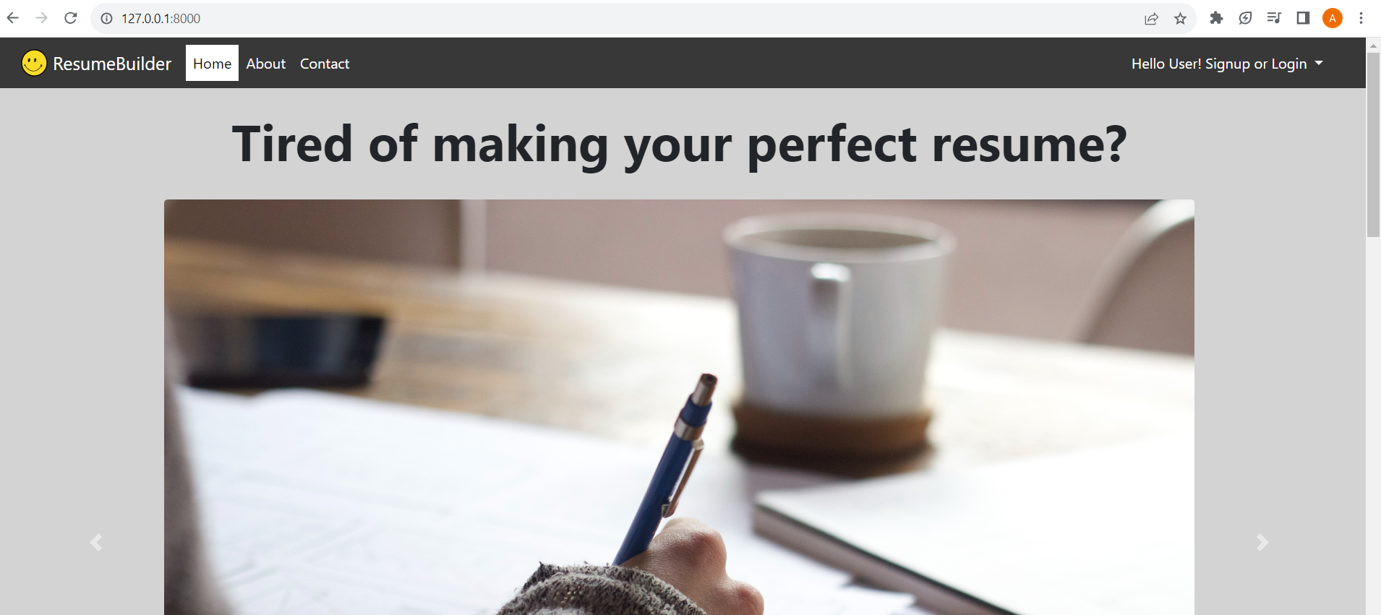

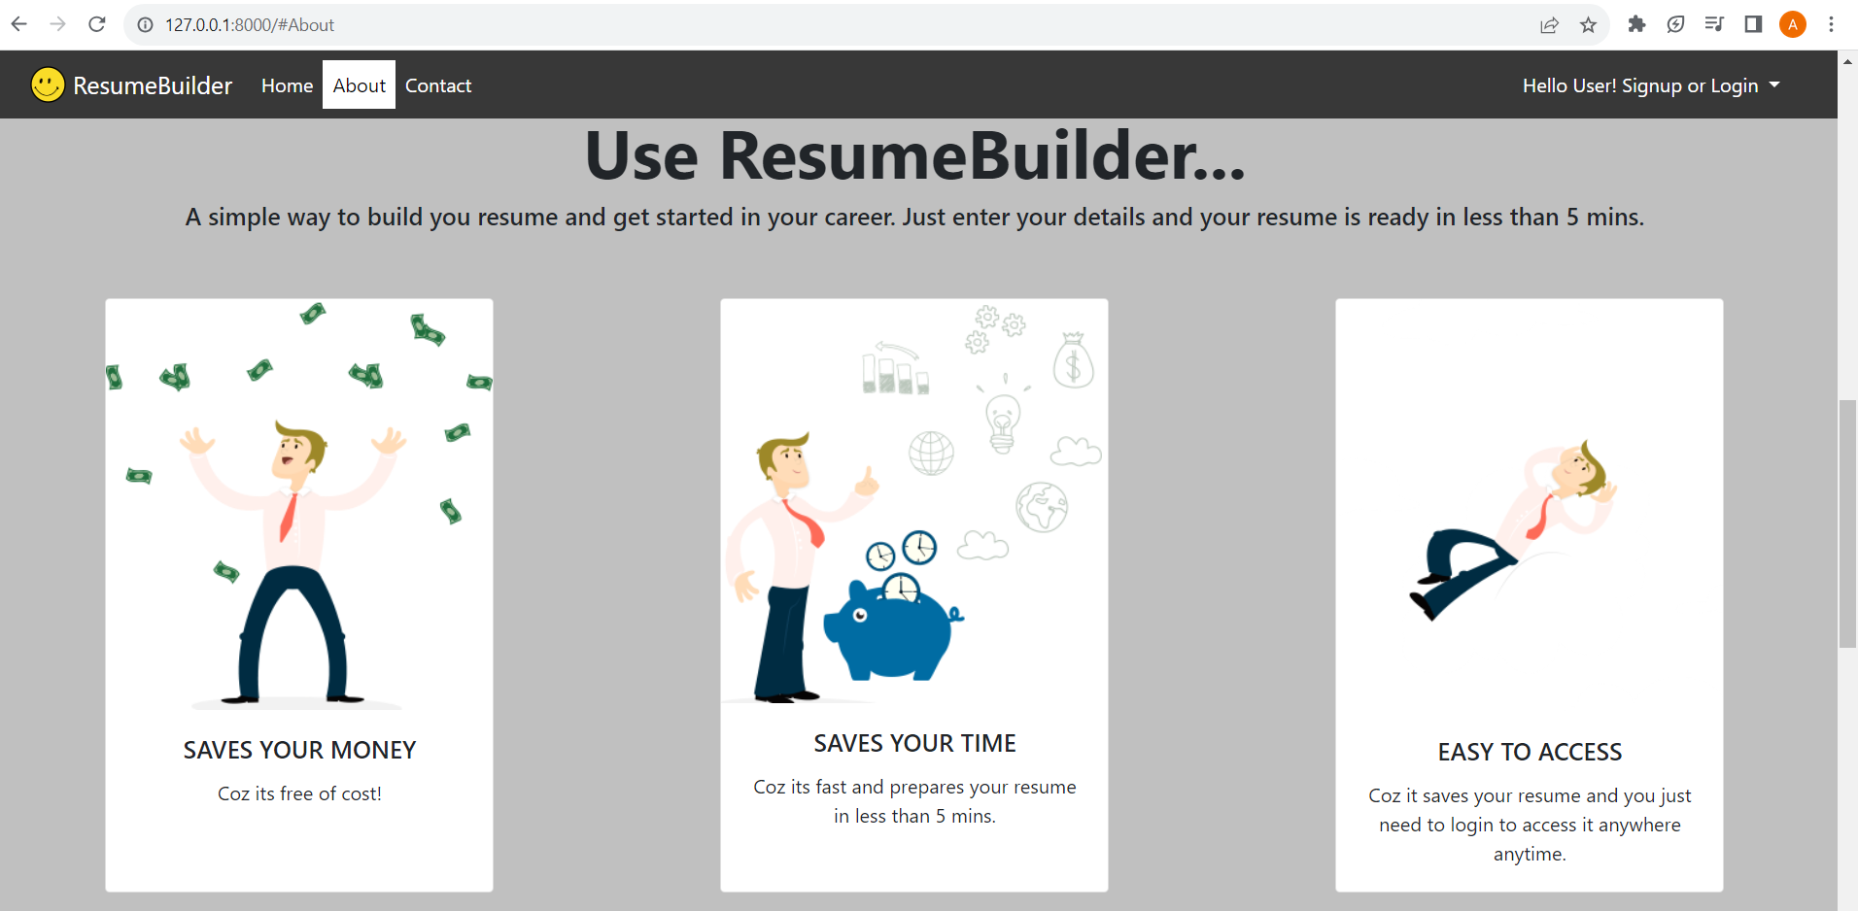

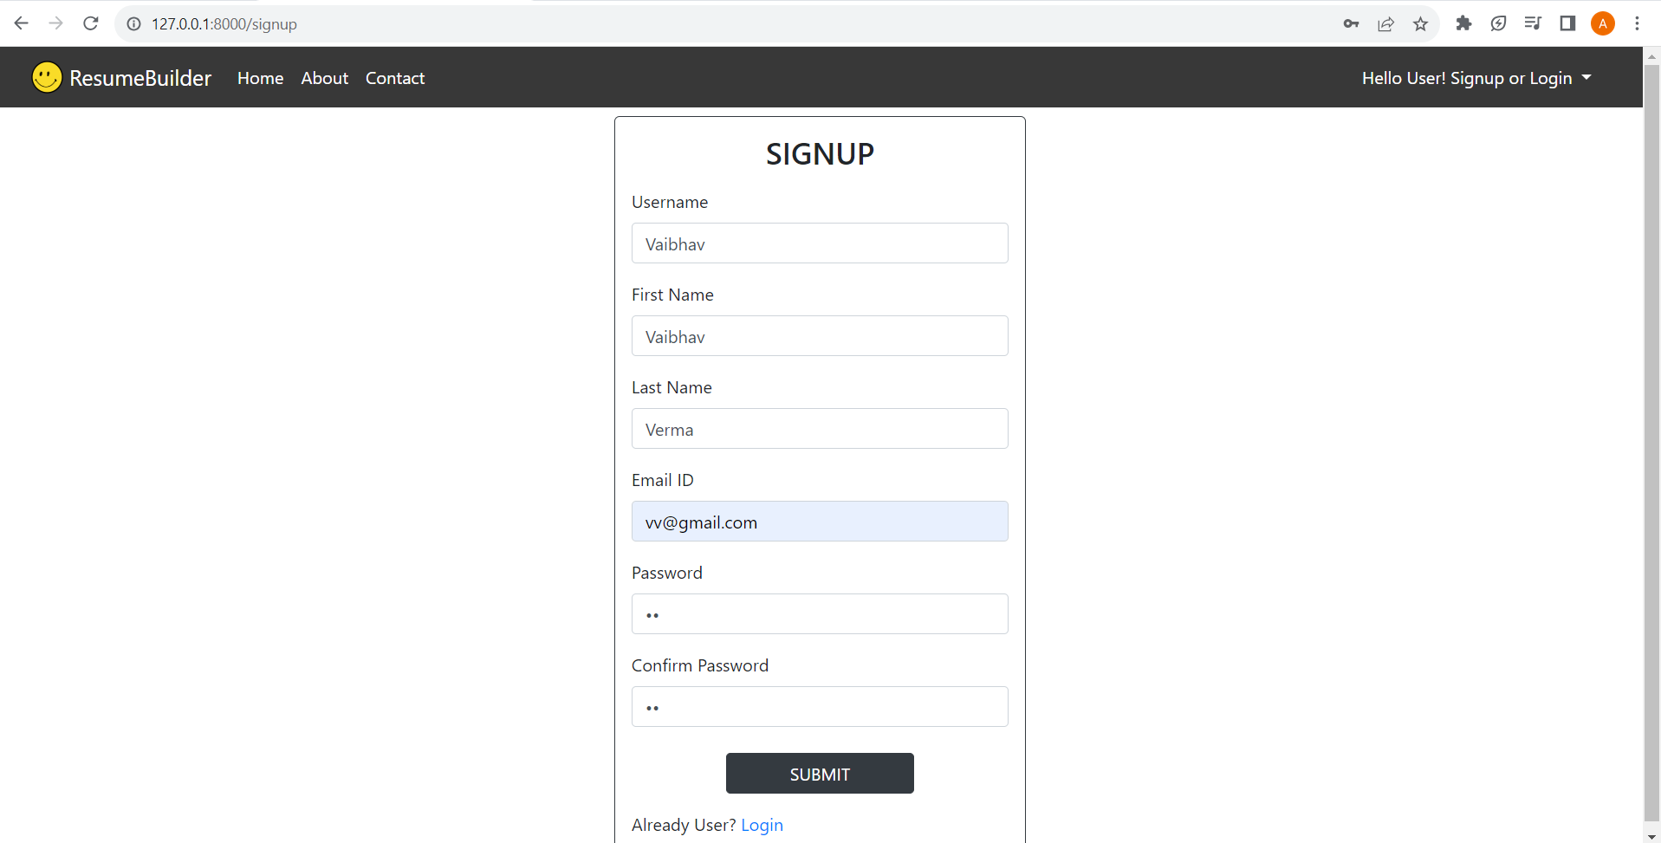 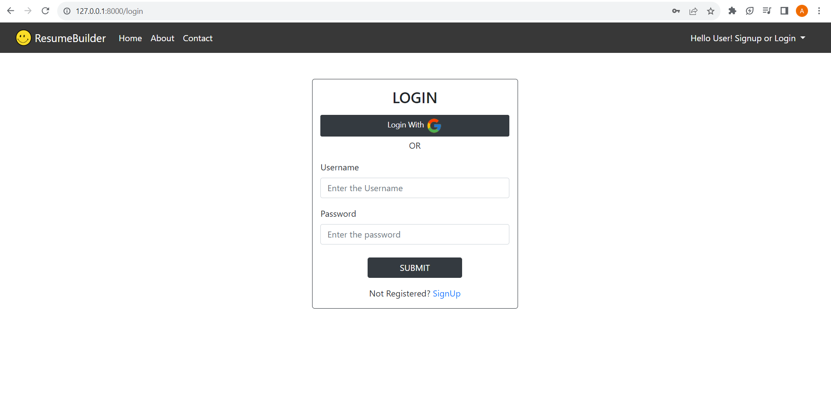

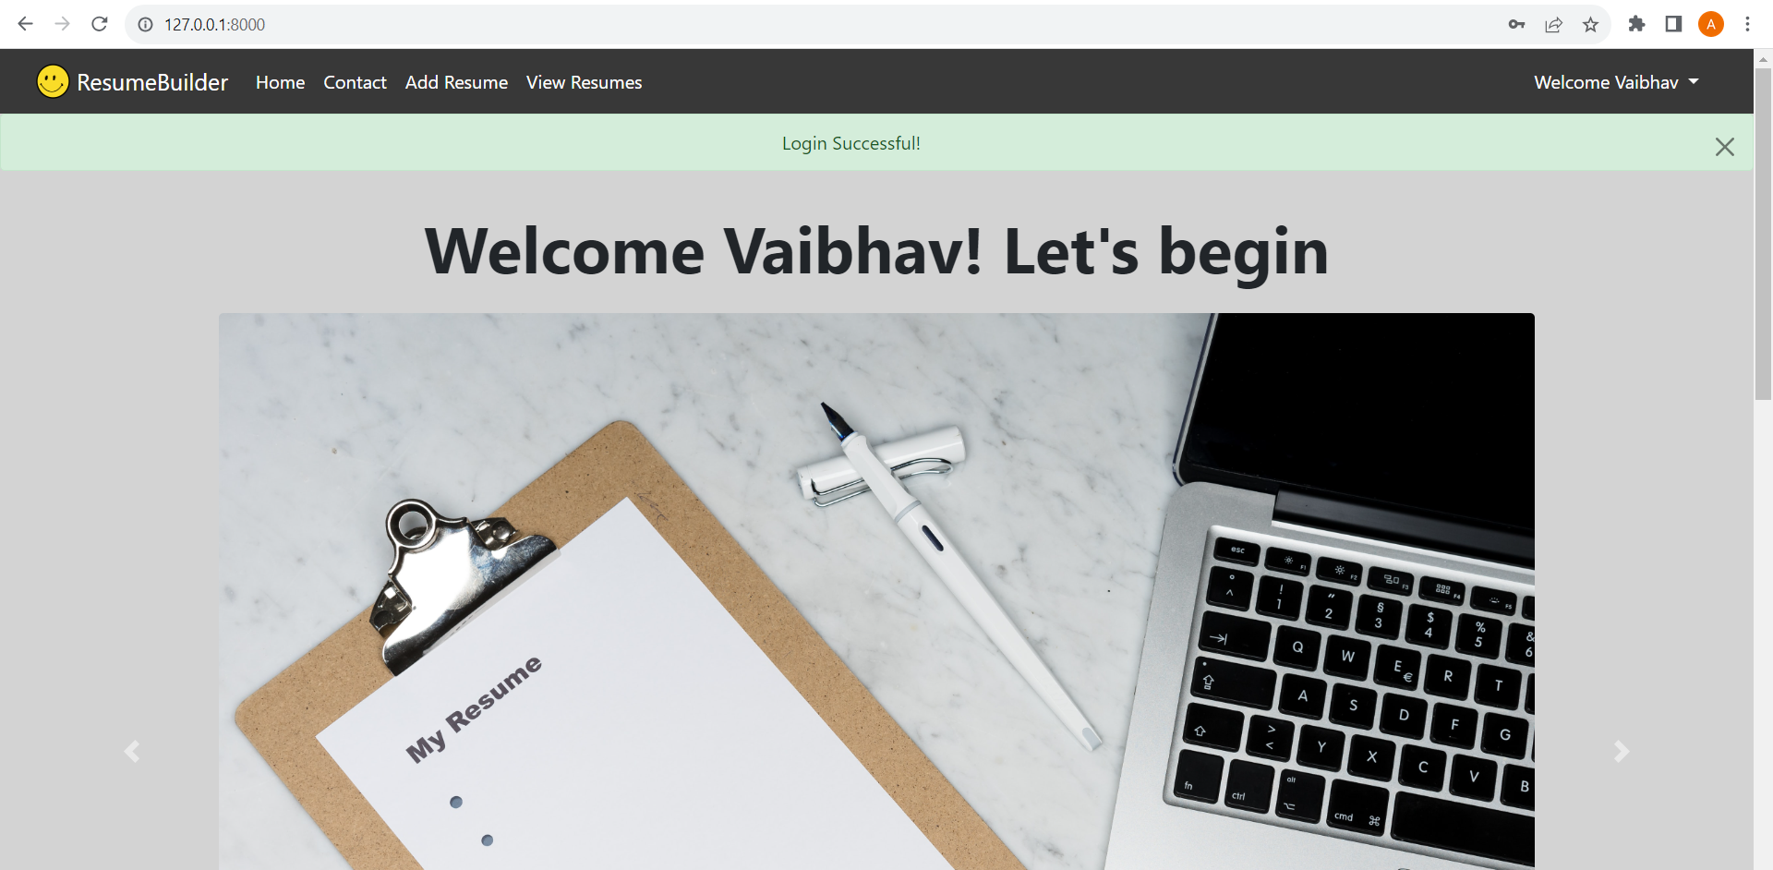

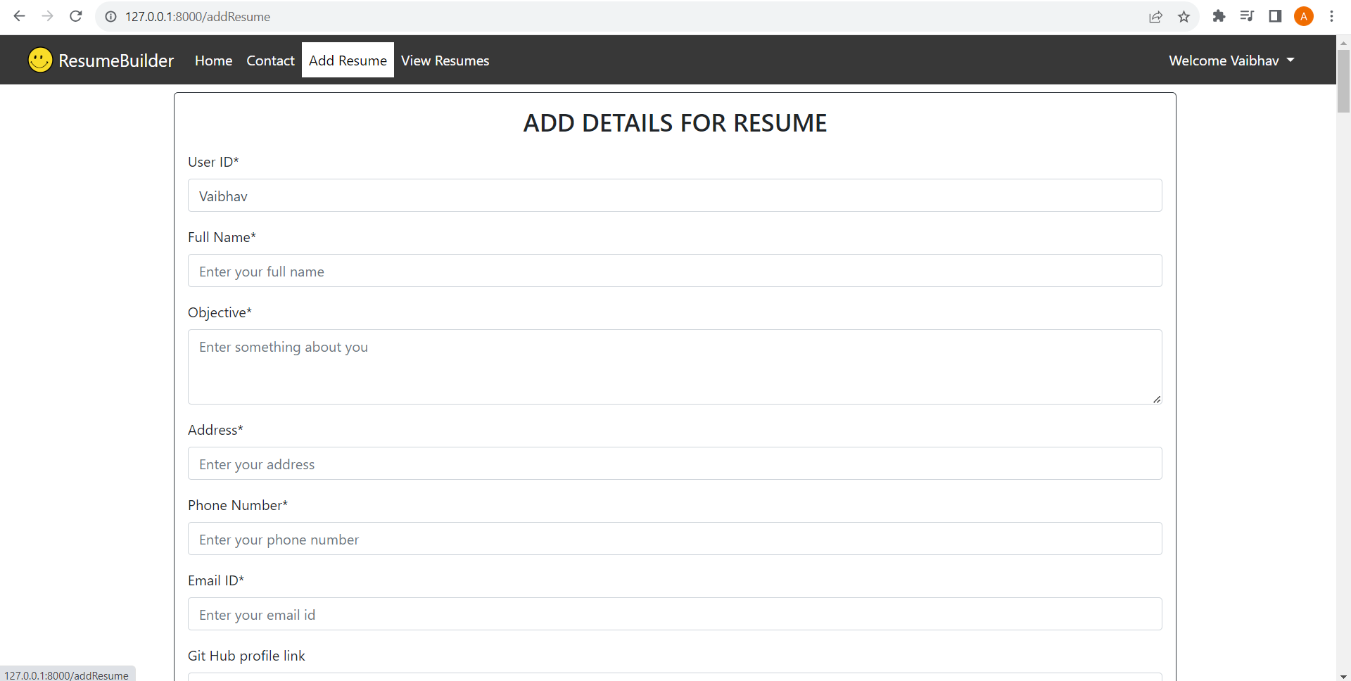

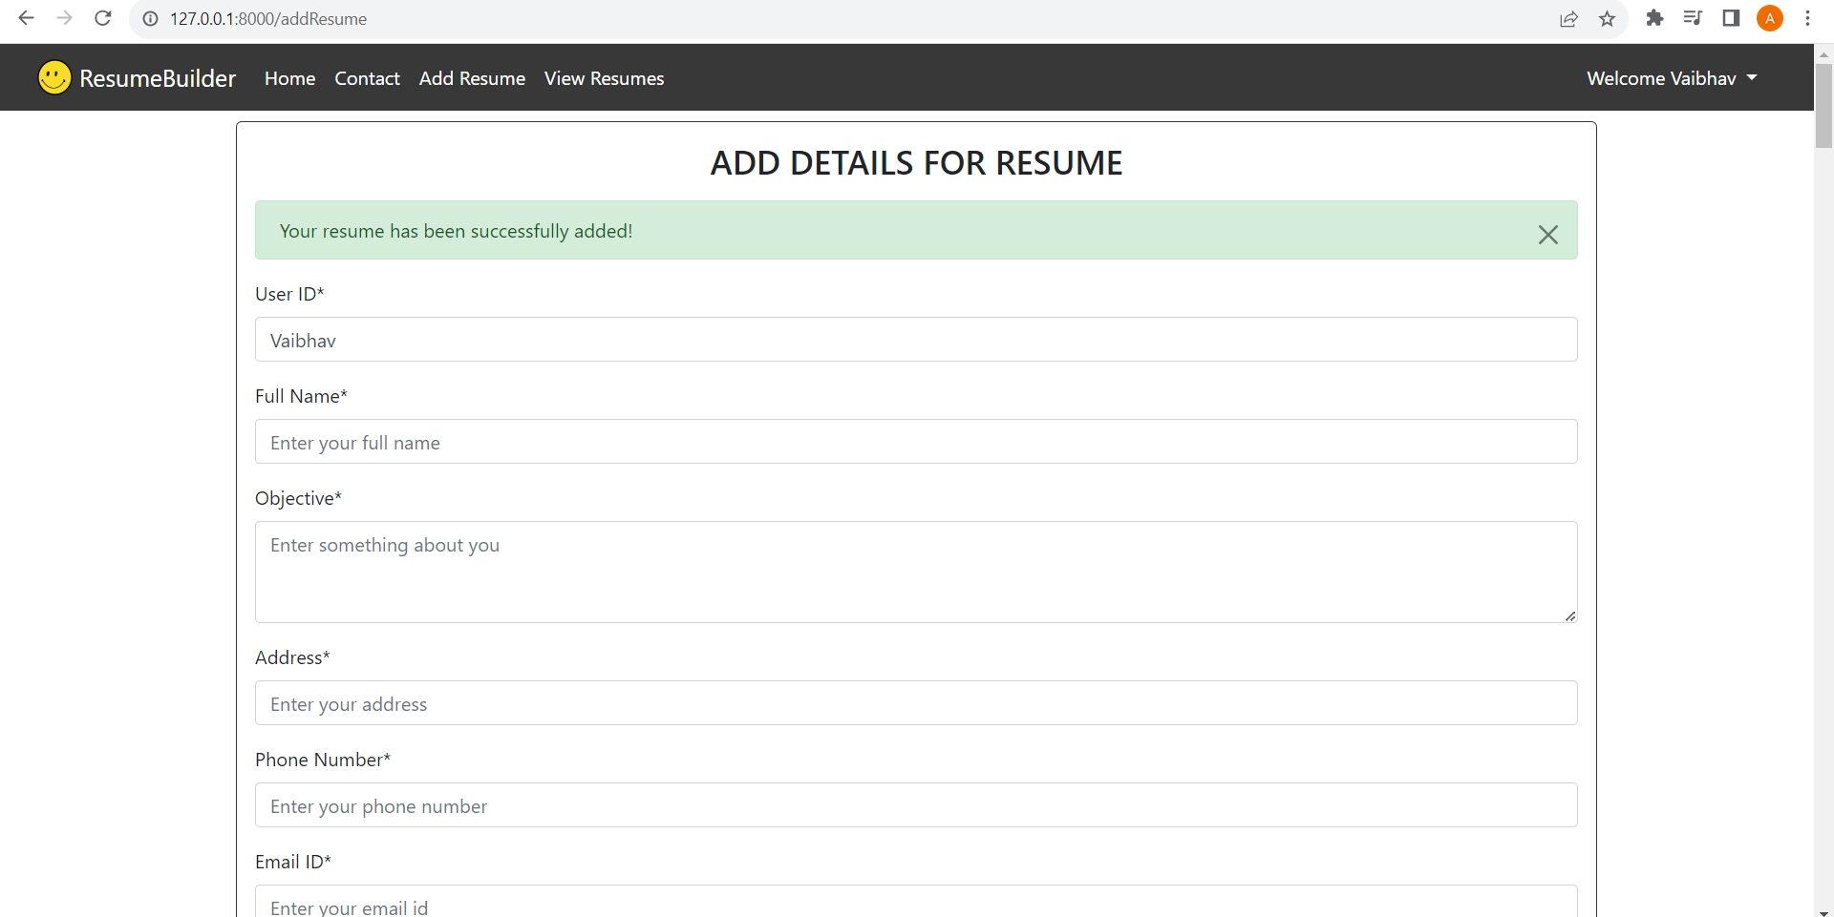

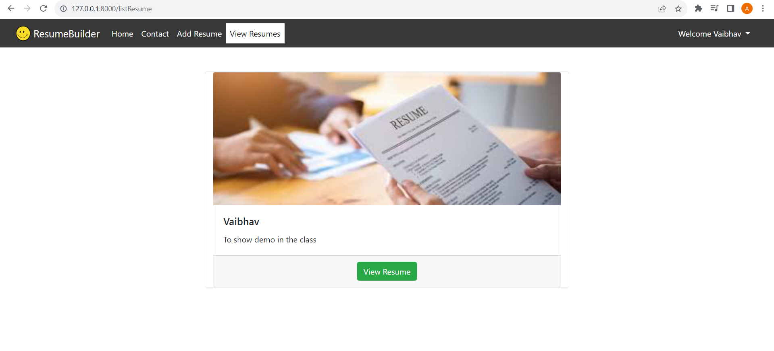

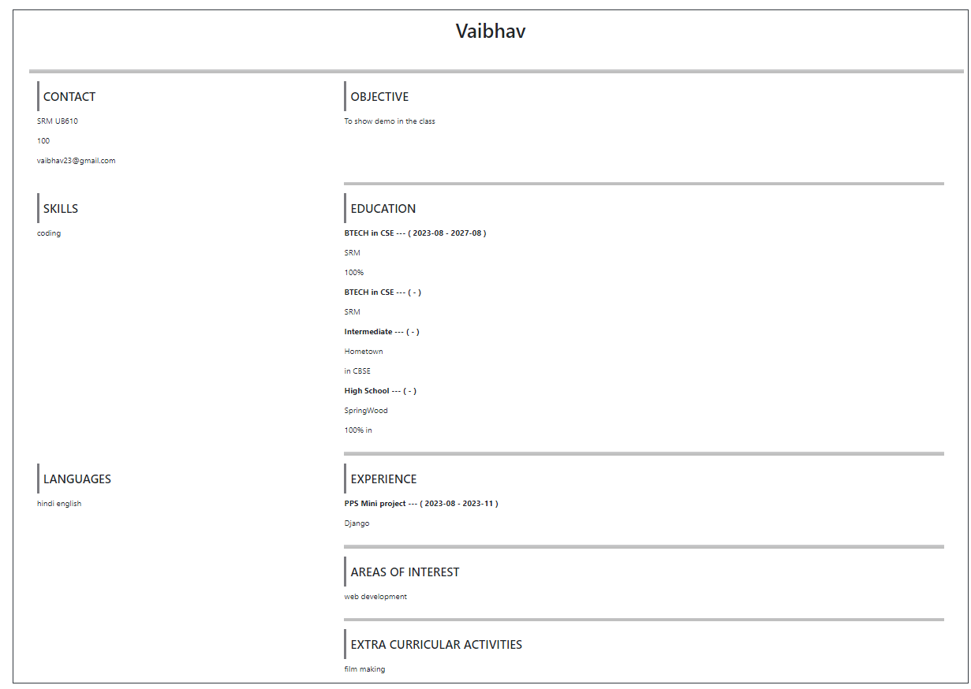

**8. Conclusion**

The completion of the web application marks a successful milestone. Users can conveniently generate professional resumes by consolidating all pertinent information in one place.

**9. References**